PROJECTDESIGNPHASE-II CUSTOMERJOURNEYMAP

|  |  |
| --- | --- |
| DATE | 2/11/2022 |
| TEAM ID | PNT2022TMID05693 |
| PROJECT | **SMART WASTE MANAGEMENT FOR METROPOLITAN CITIES** |

✴

## Document an existing experience

**TIP**

As you add steps to the experience, move each these “Five Es” the left or right depending on the scenario you are documenting.

Narrow your focus to a specific scenario or process within an existing product or service. In the **Steps** row, document the step-by-step process someone typically experiences, then add detail to each of the other rows.

**Customer experience journey map**

### Use this framework to better understand customer needs, motivations, and obstacles by illustrating a key scenario or process from start to finish.

When possible, use this map to document and summarize interviews and observations with real people rather than relying on your hunches or assumptions.

#### Created in partnership with

SMART WASTE MANAGEMENT FOR METROPOLITAN CITIES

**Steps**

**SCENARIO**

**Browsing, booking, attending, and rating a local city tour**

What does the person (or group) typically experience?

**Interactions**

What interactions do they have at each step along the way?

**People:** Who do they see or talk to?

**Places:** Where are they?

**Things:** What digital touchpoints or physical objects would they use?

**ANALYSIS OF WASTE LEVEL**

How does someone initially become aware of this process?

**garbage collection is a form of static analysis**

**determine the exact composition of a waste product.**

Identify the sectors to be reviewed. .

Recruit and inform participants

Dispose of the waste samples.

Prepare the FLW for measurement.

Obtain samples of FLW and identify a sorting site.

Weigh and record the data.

**EFFECTS FOR PEOPLE**

What do people experience as they begin the process?

% of material required by design

percentage of material purchase

Ultimate analysis informs about the amount of carbon (C), hydrogen (H), nitrogen (N), sulphur

(S) and oxygen (O)

**improper solid waste disposal and littering can cause disease- carrying pests to affect public health on a large scale.**

infectious diseases, land and water pollution, obstruction of drains and loss of biodiversity.

Toxic waste can harm people, animals, and plants, whether it ends up in the ground, in streams, or even in the air

air, water, soil or solid waste pollution

contaminates groundwater and increases the risk of contaminating wildlife's

cancer and congenital malformations.

save on costs or reduce expenses for disposal

extinction of plants and animals, air contamination and depletion of ozone layer.

creates greenhouse gas emissions and other air pollutants.

**SEPARATION OF WASTE**

In the core moments in the process, what happens?

municipal solid waste

hazardous waste

Recyclable Rubbish. .

industrial waste,

agricultural waste

Keep separate containers for dry and wet waste in the

Pursue partnership with government.

kitchen.

Keep the Waste Management Plan (WMP) Updated. .

Develop a Comprehensive Pre-incident Waste Management Plan (WMP) Use

available tools to aid in plan development.

# 

Keep plastic from the kitchen clean and dry and drop into the dry waste bin.

Send wet waste out of your home daily.

Keep two bags for dry waste collection- paper and plastic, for the rest of the household waste.

## MEASURES TAKEN

What happens after the experience is over?

reducing waste at the source

reuse of materials

recycling

landfilling.

Identify Wastes. Evaluate Waste. Manage Wastes.

Conduct Pre- planning Activities.

Prioritize plan

development.

**Goals & motivations**

protecting human and environmental health by keeping those devices out of landfills

reducing the amount of hazardous substances produced

reduce the amounts of natural resources consumed

treating hazardous wastes to reduce their toxicity

Add Recycling Bins to Public Areas. Many people prefer to choose the path of least resistance

repaired or recycled back into nature or the marketplace.

Write a Column in Your Local Newspaper or Newsletter.

to support sustainable development by promoting the rational use of natural resources,

a lack of suitable/local facilities for recycling and the time and effort spent/required in using them

Using recycling containers that register the waste by weight while providing a financial

educe the waste we produce

Implement the Waste Management Plan (WMP) During an Incident.

At each step, what is a person’s primary goal or motivation? (“Help me...” or “Help me avoid...”)

conserves natural resources.

Reduce, Reuse, Recycle

Form a Recycling Club.

Use Your Creativity.

preventing and combating the hazard and harm to health and the environment arising from wastes.

Teach Recycling to Students and Their Parents.

maximize recycling

reusing the materials taken from nature as much as it is possible

creating as minimal waste as possible.

**Positive moments**

There's an Environmental Benefit

Practice is highly lucrative

Avoid single- use food and drink containers and utensils.

Compost it!

Use a reusable bottle/cup for beverages on-the-go.

protection of human health and the environment

cost savings

legal obligations

Recycling Raises Overall Environmental Consciousness.

Recycling Creates Jobs.

|  |  |  |
| --- | --- | --- |
| keeps materials out of landfills | |  |
|  | Keeps the environment clean and fresh | |

What steps does a typical person find enjoyable, productive, fun, motivating, delightful, or exciting?

Purchase wisely and recycle.

thereby taking up less space

the protection of the environment and the health of the population.

reduces the amount of raw materials used in construction and other industries.

Saves the Earth and conserves energy

Recycling Reduces the Energy Used to Manufacture Goods.

it reduces the amount of waste that reaches landfills

Buy secondhand items and donate used goods.

[**Share template feedback**](https://muralco.typeform.com/to/CiqaHVat?typeform-source=app.mural.co)

**Negative moments**

What steps does a typical person find frustrating, confusing, angering, costly, or time-consuming?

Process is not always cost- effective

##### The sites are often dangerous

The resultant product has a short life

Needs More Global Buy-In

Waste management can cause more problems

Relying on old technologies

contributes to climate change and air

Recycling Is Costly

Extreme Weather Caused By Climate Change.

Recycling Isn’t a Slam Dunk

Recycling Takes Energy

Recycling Can Lead to Pollution

##### pollution

directly affects many ecosystems and species

a very powerful greenhouse gas linked to climate change.

considered the last resort in the waste hierarchy,

##### release methane

Human Damage.

Some “green” technologies are not truly green.

Too much single-use plastics

Flawed regulations and laws.

Contamination and improper recycling.

**Need some inspiration?**

See a finished version of this template to kickstart your work.

**Areas of opportunity**

How might we make each step

a strategic planning tool that can be used by Waste Management managers to do a situational analysis of the company

#### enables intelligently designed routes for garbage trucks based on data from connected garbage containers thanks to the collection route

to tracking activity and progress during workouts,

new opportunities to leverage IoT technology for

Improved productivity of staff and reduced human labor.

sensors detect and measure every type of environmental change.

Automating processes to reduce waste and reduce emissions.

##### collect trash

Security, Privacy and Trust.

IoT enabled Software Architectures and Middleware. .

##### Software- defined Networking.

Mobile Cloud Services.

IoT Network Design and Architecture

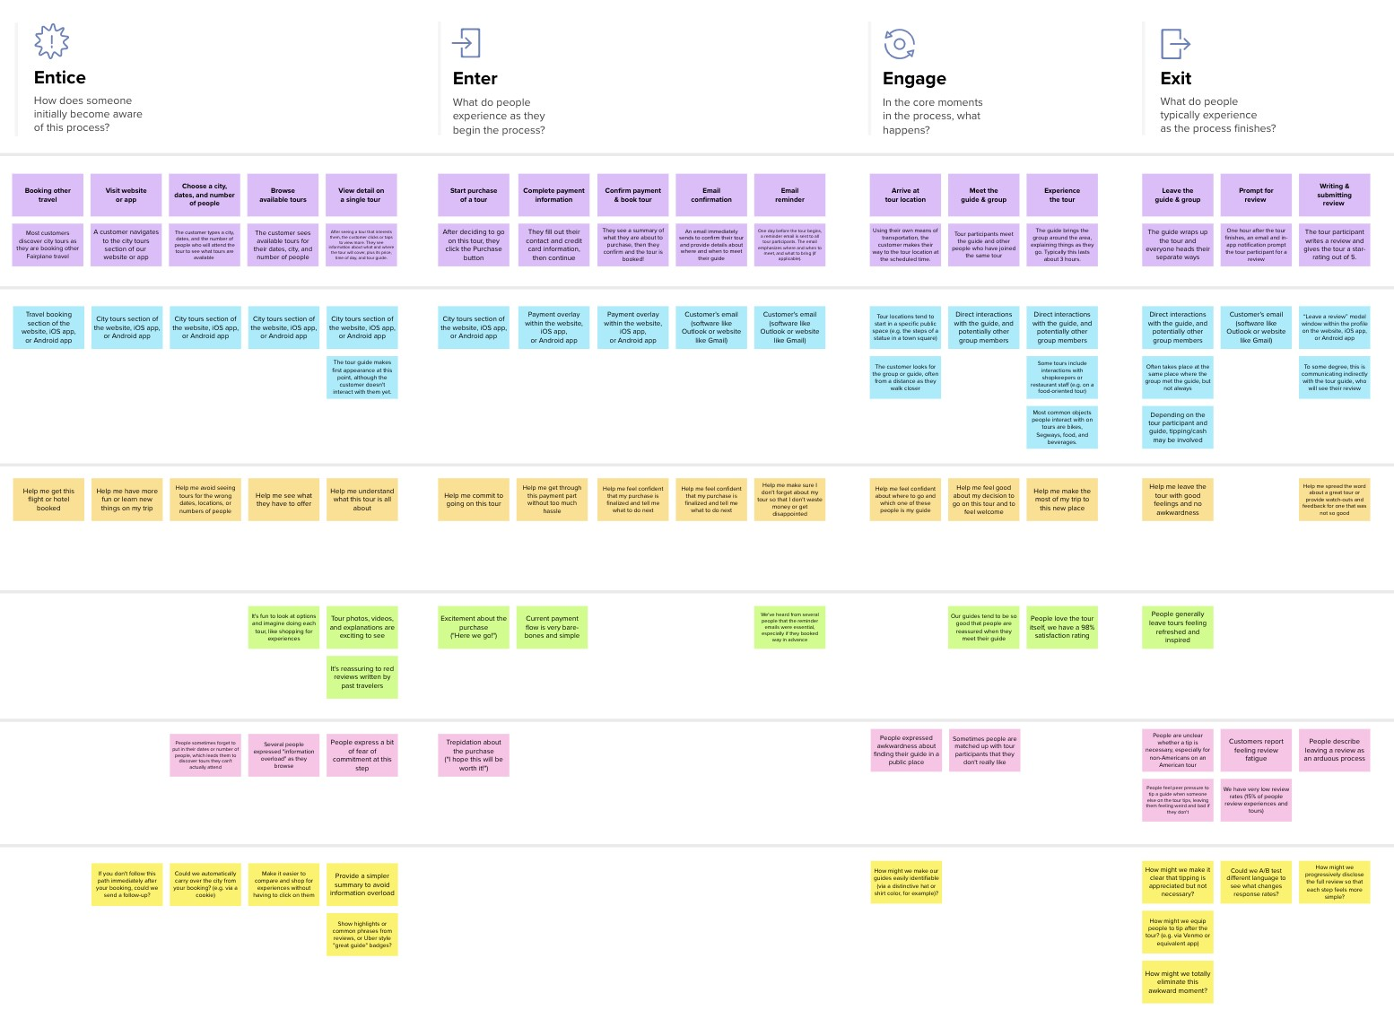

**Template**

[**Open example**](https://app.mural.co/template/f59f644b-b4b4-47b5-9ed6-3a8c71ceb612/896b31fe-5597-40ef-9b06-3811a1a45ace)